Memetic Onetai Biological Plant Fertilizer

What is It?

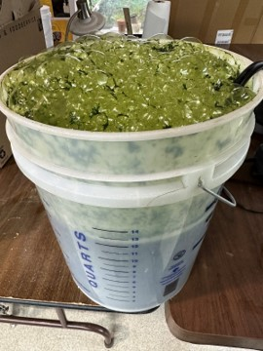
The Memetic Onetai system provides an alternative to commercial fertilizers. Using bacteria and fungi to provide the complex nutrients available in the outdoor soil environment key to healthy plants in nature. This system of mimicking outdoor nutrients in your home using easy to find materials provides a unique and readily available source of nutrients for all kinds of plants you grow.

How do Nutrients Work?

Plants need LAWNS to survive: Light, Air, Water, Nutrients, and Space. They receive most of their nutrients from the soil. Wild plants rely on decomposers to break down organic matter returning nutrients to the soil that the plants can then use. Many farmers and gardeners rely on fertilizers- some of which also use decomposers. Plants require 17 different essential elements for successful growth and reproduction. Some, like carbon, oxygen, hydrogen, nitrogen, phosphorus, and potassium are considered macronutrients because plants need them in relatively large quantities. The eleven other minerals are needed in much smaller amounts and are considered micronutrients. These elements exist in the natural world, and are recycled, meaning they are used by primary producers, eaten by consumers, and eventually returned to the soil by decomposers.

These elements are also part of commercial fertilizers, which are either mined (mineral fertilizers), produced through chemical reactions (industrial fertilizers), or made from manure and compost (organic fertilizers). Decomposers are an important part of nutrient recycling in the wild and in organic fertilizers.

Decomposers feed on dead plant material, dead animals, dead fungi, and animal waste. Some decomposers are specialists only feeding on a certain kind of dead organism and some are generalists, breaking down many different types of materials. Many different types of organisms are decomposers including bacteria, fungi, and protozoa. All of these are considered microbes.

Bacteria are single-celled organisms that can live on their own and are found almost everywhere on earth. A very small percentage of bacteria (<1%) can cause diseases in humans. Fungi can also live in many different environments. Some well-known fungi include yeast, mold, and mushrooms. Protozoa (or protists) are mainly unicellular, but there are also some multicellular protists such as kelp. Protists generally require a moist habitat and are found in any body of water even hot springs and hypersaline lakes. There are parasitic protists, such as the protist that causes the disease malaria, but many are free-living that feed on organic matter, often feeding on bacteria. Bacteria, protozoa, and some types of fungi can only be seen under a microscope, while many types of fungi can be seen with the naked eye.

Bacteria, fungi, and protozoa are important soils microorganisms due to their role in nutrient cycling. They are the characters that provide the natural world its “fertilizer.” All the nutrients the plants in the forest use are continuously recycled because of these decomposers. Modern agricultural practices have a different approach because they are trying to grow lots of food to feed our population.

Nutrient availability is often the limiting factor for plants to be able to grow in an area. To be able to grow lots of plants in a limited amount of space, farmers add fertilizer to their soil. There are many different varieties of nutrients in fertilizer, but most contain nitrogen (N), phosphorus (P) and potassium (K), which are macronutrients for plants. Farmers are harvesting most of the plants they grow, so dead plant matter isn’t always available to be decomposed, so nutrients aren’t returned to the soil. This means farmers need to add fertilizer to their soil every growing season.

Both crops and wild plants are affected by pests, which can be bacteria, fungi, protozoa, and invertebrates like insects and slugs. Farmers often spray their plants with pesticides to prevent these microbes and other pests from harming their crops. Spraying removes both the harmful and the beneficial microbes. Because these microbes are killed by the pesticides, they are not decomposing organic matter and returning nutrients to the soil.

Modern agricultural practices require a lot of input from farmers, while wild ecosystems recycle all their nutrients, and don’t require outside interference. This means the soil in the wild is teeming with “good” microbes. We want to use these microbes to decompose plants and use that as fertilizer, mimicking the way it happens in nature (Memetic Onetai).

Materials Needed

Initial Batch Ingredients & Materials – 14-day brewing process
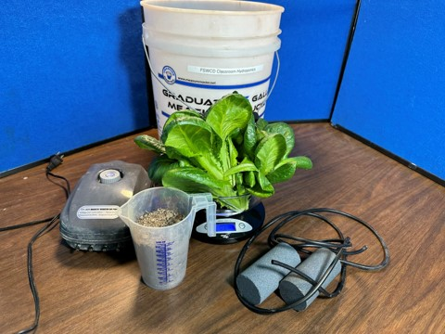
- 500g (2 cups) Health biologically active soil
- 200g (7 oz) Fresh-cut green plant material (i.e., lettuce, kale, chickweed) (~2 fistfuls of leaves)
- 15L (4 gal) Fresh water
- 5-gallon bucket
- Blender
- Airline
- Pump
- Aerating stones
- Hydroponics system/ classroom plants/ set-up for seed propagation
- Liquid bleach
- Scale
- pH strips (optional)
- Thermometer (optional; pool thermometer is recommended: can live inside the bucket)

Booster Ingredients- add every 14-28 days (add more often during heavy use)
- 250g (1 cup) Health biologically active soil
- 100g (3.5 oz) Fresh-cut green plant material (~1 fistful of leaves)
- Add fresh water as needed to maintain 15L (4gal)
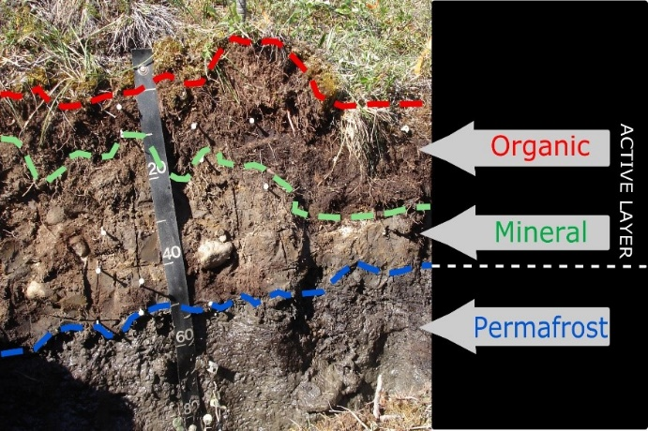
Making the Memetic Onetai system
  - Collect microbes: dig up soil from the mineral layer below the organic layer.
    - Find a mostly wild place near you (not too near roads, away from agricultural land, preferably in the forest or tundra and not on private land).
    - Remove vegetation mat and organic layer (refer to soil cross-section). Collect at least 4 cups (up to ~1/2 gallon) of “mineral rich” soil.
    - Remove major roots from soil collection.
  - Prepare water: remove pathogens that could harm your beneficial microbes.
    - The day before, take 4 gallons of water and add 2 teaspoons of liquid bleach (0.5 tsp bleach per gallon of water)
    - Allow the bleach to off gas from your water for at least 30 minutes (recommended to do this the day before)
    - This can be skipped if using city water.
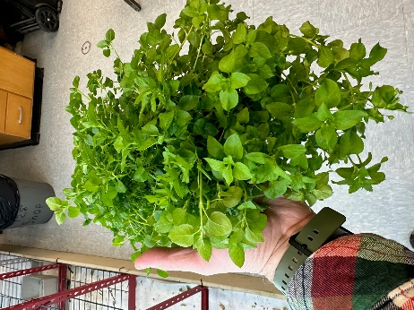
  - Prepare food for the microbes: blend plant matter with prepared water.
    - Use chickweed, clover, arugula, or other greens that are easy to grow, or you have easy access to
    - Add 200 g of green plant matter to a blender. Blend with prepared water until there are no chunks (which could clog pipes in hydroponic system)
  - Prepare bucket: Clean it and add everything.
    - Use a new bucket, or one without scratches in it. Clean with any cleaning product (i.e. bleach, vinegar/baking soda). Then rinse well.
    - Make a permanent mark at the 4-gallon line (this can be approximate)
    - Add air stones to the bottom of the bucket and hook up tubing to pumps to ensure constant air flow
    - Add soil, blended plant matter, and the rest of the 4-gallons of water

Maintaining Memetic Onetai System

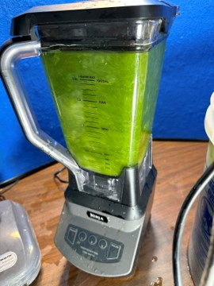
- Regularly feed your microbes with booster packs: 250g of soil + 100g blended fresh-cut green plant. Add this to the system every 2-4 weeks depending on how often you use it (feed more often if you are regularly using the fertilizer)
    - These can be made ahead of time when you make your original microbe food and frozen.
- Clean exposed surfaces if films start to form.
- Add disinfected water as needed to keep level at ~3 gallons.

Using the Memetic Onetai solution

- Apply the fertilizer.
  - to the hydroponics system at 1:16 ratio, or 1 cup of Memetic Onetai solution for every 1 gallon of water, or 1 Tbsp solution for every 1 cup water.
  - Apply it to seeds by spraying them with the full-strength fertilizer.

Signs of a healthy Memetic Onetai system

Use your senses to tell whether the Memetic Onetai system is healthy and usable.
- Smell: The majority of microbes need oxygen to propagate, so a stinky system means anaerobic bacteria have been able to thrive, while a nice forest-floor smell signals the system is healthy and nicely aerated.

- Sight:
  - Foaming & Frothing: the system should be foaming soon after feeding it. This is a sign that the microbes are breathing, growing, and reproducing.
  - Color: should be a strong ice-tea color.
    - Too dark: it is likely overfed, and the microbes aren’t decomposing all the food available.
    - Too light: there’s not enough food and the microbe colony is reducing.
  - Chunks: There should not be large organic pieces floating in it. No whole leaves or anything bigger than a pea: those items won’t decompose fast enough to be usable and might clog hydroponic pipes.
- Listen for whether the air pump is on: the microbes need air to survive.

Microbes that might be present in your soil
Bacteria  1. Azobacter chrococcum  2. Bacillus amyloliquefaciens  3. Bacillus azotoformans  4. Bacillus licheniformis  5. Bacillus megaterium  6. Bacillus pasteurli  7. Bacillus sub􀆟lis  8. Bacillus sub􀆟llis  9. Beijerinckia indica  10. Frateuria auran􀆟a  11. Paenibacillus polymyxa  12. Paenibacillus durum  13. Psuedomonas aureofaciens  14. Psuedomonas chlororaphis  15. Psuedomonas flourescens  16. Pseudomonas striata  17. Rhizoblum legominosarum  18. Rhodospirrilum rubrum  19. Rhodopseudomonas palustris  20. Steptomyces griseus  21. Steptomyces lydicus | Fungi  1. Gigaspora albida  2. Gigaspora margarita  3. Glomus aggregatum  4. Glomus claroidium  5. Glomus clarum  6. Glomus deser􀆟cola  7. Glomus etunicatum  8. Glomus intraradices  9. Glomus monosporum  10. Glomus mosseae  11. Paraglomus brasilianum  12. Pisolithus 􀆟nctorius  13. Rhizophagus intraradices (vesicular arbuscular mycorrhizal fungi)  14. Rhizopogon luteolus  15. Rhizopogon fulvigleba  16. Rhizopogon villosullus  17. Rhizopogon amylopogon  18. Saccharomyces cerevisiae  19. Scleroderma citrinum  20. Scleroderma cepa  21. Trichoderma harzianum  22. Trichoderma koningii  23. Trichoderma virid

For more information or if you have any questions, please contact Scott Faulkner at FSWCD at 907-322-4999 or email him at scott.fswcd@gmail.com

